**Virtual Lab: Temperature and Thermal Energy**

1. Log into HMH (you or your partner)
2. Use the lab to complete the worksheet (each person needs to do one, but you can discuss answers. Use your own words)

**Introduction**

*Put a check next to the answer you selected. Put a star next to the correct answer.*

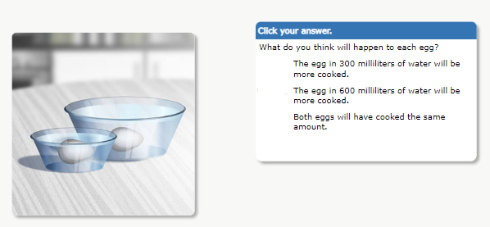

**Background**

*Put a check next to the answer you selected. Put a star next to the correct answer.*

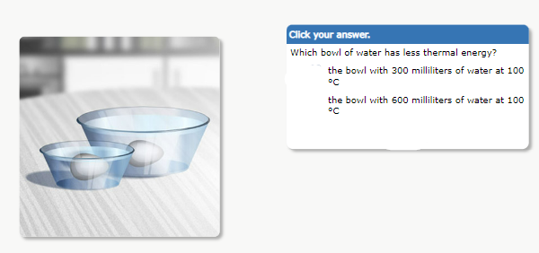

Please use complete sentences for all of the following. You may write steps for "plan your work"

| **Hypothesis**  What will happen to the temperature, as thermal energy is added to the ice over time? |
| --- |
| **Plan Your Work**  What is your plan for finding how temperature changes, when thermal energy is added to ice? |
| **Analyze your results**  As energy is added to ice, what happens over time? |
| **Evaluate your conclusions**  How does your conclusion compare to how scientists explain this? |

**Decreasing Kinetic Energy**

* Plot the change in temperature of the water in the beaker (screen 10)
* Label your x and y axis with variable and unit of measurement



| **Compare conclusions**  How does your graph compare with the graph of actual experimental data? |
| --- |